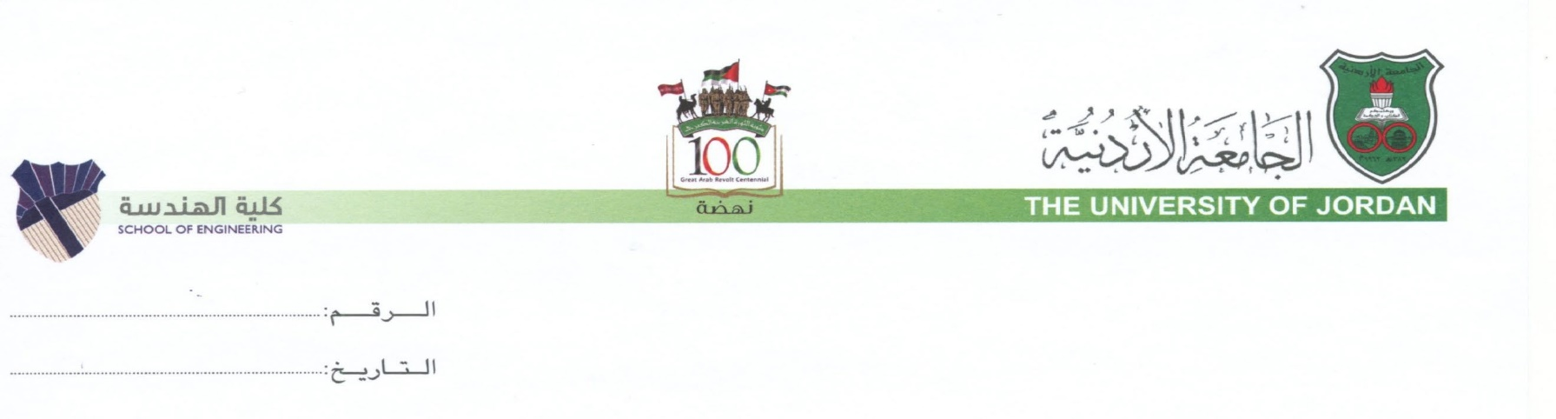
Form ENG-TR-01b

Respected .

I would like to inform you that engineering students at the University of Jordan are required to enroll in practical training (internship) in the field of their study for a minimum period of eight weeks inside the country or six weeks abroad. This is a mandatory requirement to obtain the B.Sc. degree from the University of Jordan.
I would be grateful if you could support our student ………………………………………………….., student ID number ………………. from the ……………………….. Engineering Department by offering him/her a training opportunity at your organization to work on projects and activities related to his/her field of study during the period from …………………… to ………………………..
The above–mentioned student has successfully completed …………. credit hours out of ………….. required for the completion of his/her study at the B.Sc. level.
Upon your approval, please provide our office with a tentative training program stating the tasks and duties to be performed by the trainee for our follow-up.
Thank you for your cooperation, and we look forward to continuing our collaboration in the future.

Yours sincerely,

Osaid Matar, Ph.D.

Assistant Dean for Training and Alumni Affairs

Must be stamped and signed by the Assistant Dean for Alumni and Training Affairs office

